CHINAPLAS 2019 – Hall 5.1, booth D65
Efficiency and Stability – the motan way
For more than 30 years, CHINAPLAS has been supporting the growth of the Chinese plastics and rubber industries and has become a respected meeting and business platform for these industries, contributing to its prosperous development. For motan-colortronic, the focus during the exhibition will be on "efficiency and stability", highlighting the Permanent Central Vacuum System, which is particularly suitable for high production capacities. In addition, the best-selling product - METRO G and the energy-efficient central LUXOR drying systems and many more will be presented.
Permanent Central Vacuum Systems – reducing energy costs and production downtimes
Those who rely on Central Vacuum Systems clearly invest in high efficiency and reliable systems. motan is one of the suppliers of these complex centralised material feed systems. Each system is designed to suit the customer by considering individual factors such as throughput, materials types, and plant layout. A wide selection of loaders with a variety of conveying options, controls, blowers, and filter techniques allow the creation of the optimum system for the customer’s facility.
The advantages when compared against conventional line vacuum systems are obvious: a well-arranged, compact Central Vacuum System with an optimum conveying capacity and maximum reliability. Consistent low-pressure control for example, will provide automatically need-based generation of the convey air quantity through speed control and switching on and switching off the blowers. By doing so, energy costs as well as the power required for the process are drastically reduced.
In addition, the service required is reduced to a fraction of what is needed with individual blowers. And no production down times when servicing components of the vacuum system. Only a few uniform system components which require maintenance or replacement, lead to a better manageable and less cost-intensive spares inventory.
One point, however, is of crucial importance: the design of a vacuum system must always be tailor-made for the customer. Here, motan can help with expertise and experience.

Drying plastic granulate the efficient way - with LUXOR A
LUXOR A series dryers with ETA-process® and ETA plus® energy saving technology are specifically designed for supplying dried plastic granulate for many different plastics processing applications. They have either two or three fully insulated stationary desiccant beds with separate process and regeneration blowers which provide consistently low dew-point air to the process, while reducing energy consumption.
The advanced LUXOR A series consists of ten models with drying capacities from 80 to 2400 m3/h. Each advanced system dryer can be flexibly combined with all LUXORBIN A drying bins from 15 to 2400 liters. At the exhibition motan-colortronic is showing the LUXOR A 160 variant.

METRO G – configure the right material loader
The modular building block system of the METRO G allows users to configure and create the optimal material loader for any application. For example, a standard material loader unit can be expanded into a clean room version just by adding special vacuum diaphragm valve. A dust removal module provides for fine dust removal at the material loader, essential for some critical engineering plastics where absolutely no dust is allowed to enter the process. The system can also be fitted with modules with a tangential material inlet to provide a cyclone effect for processing those materials where a more coarse dust separation is required. METRO G allows users to configure the right material loader for any their specific application.

The dosing unit SPECTROFLEX V with new flexible exchange system
Whether powder, pellets, regrind, granulate or fibers – the new SPECTROFLEX V is the volumetric dosing unit for continuous processes, designed for many different applications. Should material colour, flow properties or grain size change, then motan´s unique exchange system offers a simple way to swap materials without the need of tools in under a minute.
The single- and double-screw exchange modules as well as the easy-to-clean supply hopper allow for fast and easy material changes and so reduces production downtime.

The next level in material selection – METROCONNECT U/C
With the new material coupling system METROCONNECT U/C, motan-colortronic provides a high-quality, manual coupling station for vacuum conveying systems. Easy to use, safe and reliable in the process even for difficult materials. It forms a cost-effective solution for central material supply. The customer can choose from an uncoded version and a coded version with RFID technology.

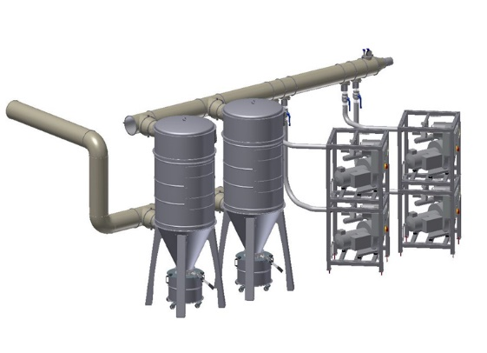
Photo 1: Permanent Central Vacuum System – sample configuration
(Image: motan group)
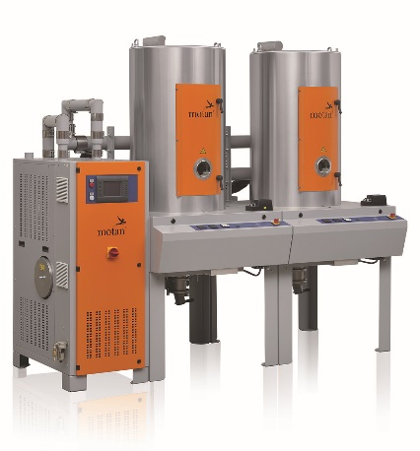
Photo 2: LUXOR A 160
(Image: motan group)

Photo 3: SPECTROFLEX V – motan’s volumetric screw dosing unit
with flexible PU dosing hopper
(Image: motan group)

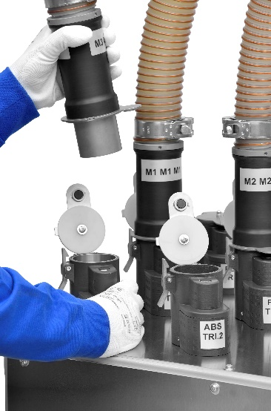
Photo 5: Coupling system METROCONNECT U/C: Simple and process-safe handling - with or without RFID coding. (Image: motan group)

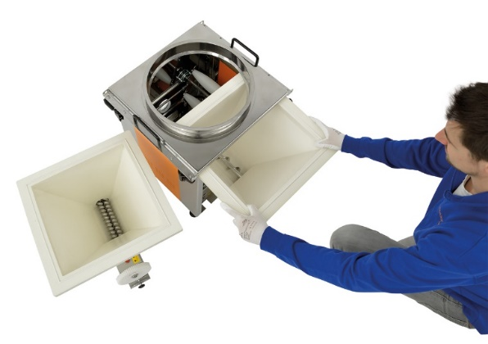
Photo 4: SPECTROFLEX V exchange modules –can be swapped easily in under a minute (Image: motan group)

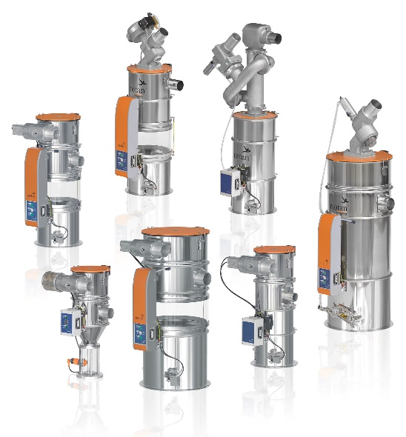
Photo 6: A small selection from the METRO G building block system (Image: motan group)

The motan group
The motan group based in Constance was founded in 1947. As leading provider for sustainable raw material handling, they operate in the areas injection moulding, blow moulding, extrusion and compounding. Innovative, modular system solutions for storage, drying and crystallisation, conveying, dosing, and mixing of raw materials for the plastics manufacturing and processing industries are part of the application orientated product range. Production takes place at different production sites in Germany, India, and China. With 540 employees currently, a yearly turnover of roughly 132 million euros is achieved. Thanks to its network and many years of experience, motan can offer its customers what they really need: tailor-made solutions with real added value.
Taicang Motan-Colortronic Plastics Machinery Co., Ltd was founded in January 2006. The object of the company is to provide high-quality equipment and professional solutions to Chinese customers through local production and service. Main products include: dry-air dryers, dosing and mixing units, vacuum hopper loaders and central conveying systems.

Contact:
Taicang motan-colortronic
plastics machinery co., ltd
Sally Ji
Marketing Supervisor
Building 15, 188 Guangzhou East Road, Taicang Economic Development Zone,
Taicang, Jiangsu Province, China

Tel: +86 512 5363 2377

sallyji@motan-colortronic.com.cn
www.motan-colortronic.com

